Pack-Run Family Sign-Up Event Plan + Script
Yes, Pack Volunteers Run Sign-Up Nights
Council Professionals and District Volunteers Coach and Support Packs
Part of the coaching and support from your Council and District is providing this Sign-Up Event Plan and Script that you can download and edit to fit your Pack and what makes you unique: your Program Plan, your People, and how you do Cub Scouting!. |  |  |  |  |  | 
This Pack-Run Sign-Up Event Plan and Script can work at any Sign-Up Events, both:
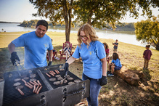 |  |  | Pack Fun Sign-Up Events with new families before or after any School Sign-Up Night – like a cookout or swim party or bike ride or game event. Sometimes called “Back to the Pack, these can be longer with fun activities for kids + families – and can include “Pack Parent Orientation” time if you want.  Any Fun Den or Pack Event can be a Welcoming Joining Event!  With a small group (like just new families at a Fun Event), you can further tailor what you say – but this makes a good checklist.
A School Sign-Up Night that your Pack schedules with your School and your District Team – the District wants every School to get a chance to join Scouts.  Note: most schools need these to be quick events since they are “after hours” and require paid staff to stay late.  This Pack-Run Sign-Up Script works for quick events. |  |  |  | 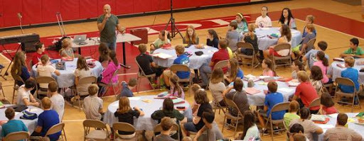
- Make a Calendar of Fun Activities that families like – your Pack’s program. Planning Elements include:
- Your Monthly Big Fun Activities through next summer, plus Sign-Up Events, Back to the Pack Fun Days, Meeting Days and other events like Service Projects and Blue + Gold Awards Banquet.
- Determine your Budget and how much Pack Families need to pay for local program fees or dues.
- Let People Know – Promote Your Program! Start when you have a Program, go big as school returns.
- Make a Pack Packet – a one-page (two sided) flyer with pictures, key contact + event info and a QR code.
  - Your Pack Packet should show some pictures of your families enjoying Cub Scouts – and list your key Pack Fun Activities (include those still in planning) plus contact information to reach key Leaders.
  - A QR Code can link to Pack info – the FAQ about “How Your Pack Scouts” – with detail about Activities, When + Where You’ll Meet, Pack program fees (dues), fundraisers, uniforms, advancement and dens.
  - The QR can link to a Website or it can launch an email to you – then you can reply with information.
- Don’t forget to update your BeAScout Pin and Online Registration Tools and Emails.
- Gather and launch other promotion items like social media posts (encourage parent posting), “Join Cub Scouting” signs, plus the “Sign-Up Event” flyer that your District Executive can create with your input.

- Recruit More Leaders and Helpers - one by one, find ways parents can help their Den and Pack.
- Develop your Every Parent Helps policy, use a parent skill survey or other list of Pack and Den Team Roles or “pledge card” for parents to pick from as they join the team.
- Show all “open” positions and be creative about “slicing and dicing” roles so that parents say “oh, I can do that!” and not “no not me – that job is too big”. Tip: Advertise for “Den Co-Leaders” and a team!
- School and Community Presence – show them the Fun of Cub Scouting, and you’ll get more support.
- Good relations with School Staff are key to the Playbook for School Sign-Up Nights.
- Includes school scheduling with your District Pro, and confirming your dates are still good with the school.
- You Are Here: Step Five is Sign Up Events – yes, you should have more than one (at least one with fun!)
- Have you edited the Script below to fit your Pack – especially your activities and your local program fees?
- Do you have a Team trained to put on the Sign Up Event, including Welcome Greeters, Presenters (at least 3), Application helpers, printers, décor and signage? You’ll need at least 6 on the team – more is better!
- Print handouts: your Pack Packet, Youth and Adult Applications, Parent Skill Survey or other leader volunteer resource like “Every Parent Helps, maybe some Bobcat Den Meeting plans.
- You’re collecting Scouting Registration and/or Pack Dues – have a Mobile Credit Card Reader / Card Swipe.
- Do you need Professional help? Contact + confirm what they will provide among: Slime Toys, Handbooks, Pop-Up Banner, Yard Signs, Parent Orientation Guides, Waffle House Cards, Braves Bookmarks, Stickers.
- After your Sign-Up Events (or alongside your final Fun Sign-Up), have a Parent Orientation ready to go!
- Step Six is More Fun Events. Every Fun Den or Pack Activity can be a Welcoming and Joining Event.
- With a foundation of a strong activity calendar that families want to participate in and a team of leaders they want to help, you’ve got a Den and Pack Program that families will want to join.
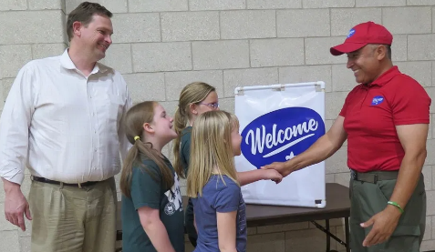 |  | Sign-Up Events should aim to recruit new families.  - Youth and Parents! Cub Scouting is a family program.  - Without parent leaders, a Pack can’t have a Scouting program.  Capture the imagination of parents about the value + fun + adventure of Cub Scouting, so that they join together with their children in Cub Scout activities.
Suggestion for adult leaders who want to recruit parents as leaders:  - Wear regular clothes, not uniforms, so parents see that “you’re a regular person just like them” and they too can be leaders.  - Don’t let them think “those khaki wearing people are the Scout Coaches – so we don’t need to be part of the Leader Team.”  - You may not have a full slate of Pack and Den Leaders at the start of school … few Packs do. Keep trying! |  |  |  |  | 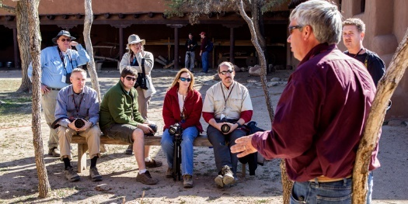
- We suggest a Pack “Every Parent Helps” policy.
- Your level of engaged Pack and Den Leadership will affect how you pitch families. Packs with lots of leaders can give a quick pitch about parents stepping up to be leaders. Others need more leader recruiting focus.
Each Pack is different, so revise this Plan and Script to reflect your Pack’s program and needs (especially leader needs) and coordinate with any District Helpers who attend so that they echo your Pack program.
Packs that need den leaders will need a stronger pitch for leaders – we have options in this script and more

Set Up the Space. Arrange the space to make the event work for you and the families:
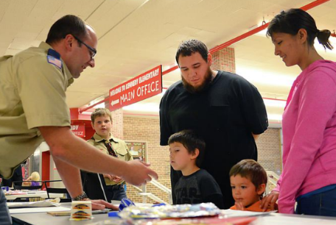 | - A “Welcome” table – with sign in sheets + Greeters near the entrance.  - Get names of everyone on your Sign-Up Sign-In Sheet – kids and parents (plus grade, phone # and email) – key to “follow up” invitations.  - Your greeters might also note “leader prospects” as you meet them.  - Multiple Welcoming Parents and Families is a huge help!  - If you have a “kid play” area, returning Scouts can take new kids there!  - Returning parents can take new parents and introduce them to others.
- Projecting pictures and video of your Scouts in action is powerful.  - Online applications through BeAScout are efficient – National fee collection is done directly online.  - Bring a How to Sign Up Online handout to help families register online.  - Check: Can you login to BeAScout? Share any Wi-Fi password. |  | 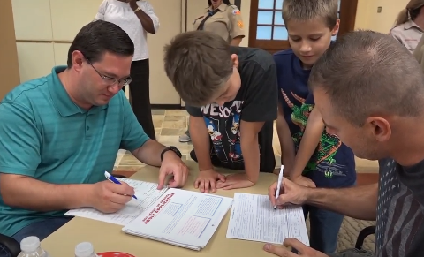

Presentation Set Up: Set up groups of tables for each grade (to let den families get to know each other).
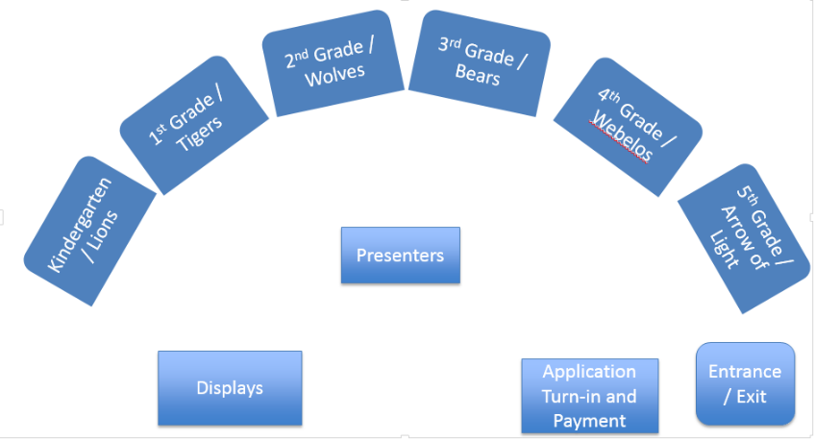 | Make signs using both Grades and Den names:  “Kindergarten = Lions!”  “First Grade = Tigers!”  “Second Grade = Wolves!”  “Third Grade = Bears!”  “Fourth Grade = Webelos! (or WE’ll BE LOyal Scouts!)”  “Fifth Grade = Arrow of Light!”  Have families of current Scouts sit with new families to welcome and answer questions.

Station to Station Set Up: Have tables for the topics listed below, with signs for the “table topics”.
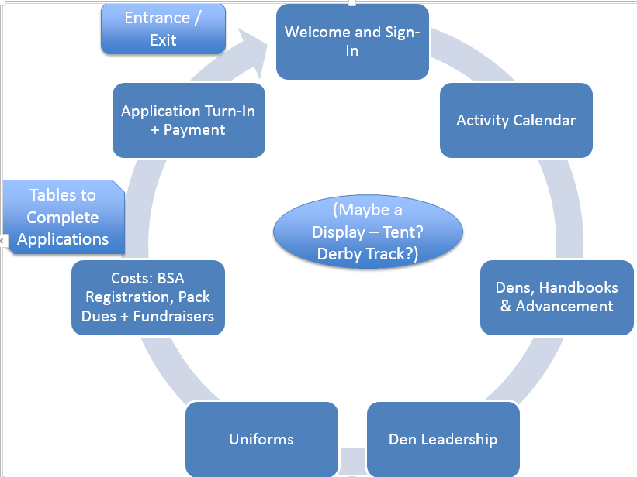 | With enough help and tables, expand with separate Den tables for Lions/K, Tigers/1st, Wolves/2nd, Bears/3rd, Webelos/4th and Arrow of Light/5th  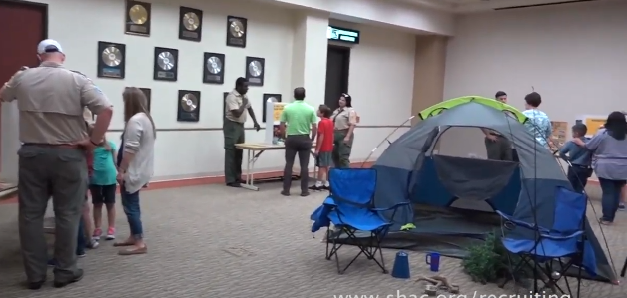  This can work outdoors too  Station Helpers Point Families to the Next Station
Welcome + Goodbye Station: “Entrance/Exit” is a key spot to staff well in each layout. Greeters need to welcome both coming and going; to be sure you’ve captured them on your Sign In Sheet and can follow up.

People you want to have at a Sign-Up Event
- Cubmaster, Chair, any Den Leaders, Assistants + Committee already recruited have the key speaking roles.
- Parents can make up a Welcome Team to greet families and help answer questions peer to peer.
- All Current Pack families to help welcome new families. Parent to Parent. Kid to Kid, hopefully having fun!
- Use a playground or room where new and returning kids can play games + have fun! + make friends! Members of a Scouts BSA Troop and parent helpers can watch the youth and let parents focus on the presentation.
- District Helpers like your District Executive, Membership Committee Helpers, and Unit Commissioners can play a role at Sign-Up Events, by sharing resources like this, coaching speakers, and supporting as needed.
Script Outline. The script below has the following sections – please edit to fit your Pack:
- Welcome and Overview of Signup Event  - Pack Activity Calendar Highlights  - Dens, Handbooks & Advancement  - Den Leadership  - Uniforms  - Costs (National Fees and Pack Program Fees)  - Close the Sale (Collect Applications + Fees) | These script ideas can work for:  - a group presentation to everyone indoors or out  a “station to station” signup event, using the individual topics as your “stations”, ideally with handouts at each
- For group presentations, give speaking parts to more than just the Cubmaster and Chair – sharing speaking roles reinforces the idea of shared leadership by parents! But Keep it Brief and Crisp!
SCRIPT: Sign Up Event Presentations (or Station to Station Presentations)
- Welcome Team parents greet families, get them to “sign in”, deliver handouts, and guide to den tables with others at their grade level (or topic tables in a “station to station” format).
WELCOME GREETING  Cubmaster or Chair  (2-3 min.)  Note: The script here is for a “group”.  A one-on-one welcome, or a “welcome station” at a “Signup and Applications” table would be very informal.  Be sure to capture “applications and payments” when people depart! | “I’m ___ and I’d like to welcome you to the Pack __ Cub Scout Sign-Up. Today you can:  - Learn about Cub Scouting and get a calendar that shows our Pack activities this year  - Get to know our leaders so far and find out how you can help bring the fun  - Sign-Up with us and fill out an application to join”  “First, let’s open with the Pledge of Allegiance and the Scout Law. (Lead each.)  Second, let me recognize some of our parent leaders and helpers here: _______________. All of them are happy to talk with you and answer your questions about Cub Scouts.  - “Cub Scouting is pretty simple: If it’s fun for kids, fun for families, and safe – then it’s Cub Scouting. Scouting is called a “Game with a Purpose” … in Cub Scouting, our game is to have fun with families while raising our kids …for our kids and parents to make friends with other kids and parents … we’re here for the whole family!  “In Scouting, we also teach the values of the Scout Law: Trustworthy, Loyal, Helpful, Friendly, Courteous, Kind, Obedient, Cheerful, Thrifty, Brave, Clean and Reverent.  - [OPTIONAL: “How many here are Eagle Scouts? How many were Cubs or Boy Scouts as kids? Girl Scouts? Fantastic! You know your kids are in for a great adventure.” (Take notice – these may be targets to recruit to be leaders!) end Option]  “You’re here, and we want to be sure we’ve got your contact information to stay in touch with you, and we hope that you will join up with us with applications and payment.  - [BE SURE YOU HAVE THESE ON HAND: “We also have a special fun item for kids plus free Handbooks if you sign up tonight and pay the National Scouting fees.]  - [OPTIONAL (if you have someone leading kids in games): And let me introduce ___ and ___ who are happy to lead your kids in some games <_outside? In the gym?_>.]
[OPTIONAL (if you like this)  NOISE + CUB SCOUT SIGN  Cubmaster or _____  (2 min.) | “Let’s see what kind of a group we have … can we ‘make some noise’? In Scouting, we do cheers, so let’s do The Neckerchief Cheer. Here’s how it goes: I’ve got this Scout Neckerchief, and I’ll throw it into the air. When I do, I want everyone to cheer and yell and clap as loud as you can – but stop if it hits the floor or I catch it. Let’s try!”  - “Great job! But now, let’s get quiet. We use the Cub Scout sign to get your attention.  - “The 2 fingers represent the ears of a wolf. Like a wolf, we get silent to hear. When we need attention, we hold up this sign and the Pack should go silent in order to hear.  - “Let’s practice. Make some noise!” (Let all get noisy – hold up the sign until quiet.)
PACK ACTIVITY CALENDAR  Pack Volunteer: _____________  (2-3 min.)  Stations: could be at a “Pack Activities” table | “Let’s Talk About What We Do! We’ve got handouts with our calendar of fun events. Please hang onto this – and call me or any other leaders if you think of questions afterward.  - “You’ll see that our fun events and weekend activities are for the whole family … not just kids, but parents, siblings and more (briefly pump up a few key fun activities for the year: your Pack’s camping trips, pinewood derby, summer camp, hikes, biking, fishing, etc.).  - “Now, these are just what’s planned so far – you guys will also have great ideas of more fun things we can all do together.  - If there is something you like to do or want to do, let’s try to do it. Whether all of us together as a “Pack”, or in your Grade Based Dens.
DENS (based on School Grade), HANDBOOKS & ADVANCEMENT  Pack Volunteer: _____________  (2-3 min.)  Stations: this info could be at a “Handbooks / Advancement” table | “Let’s cover how our Cub Scout Pack is organized. Your child will do age-appropriate activities and advancement with others from the same grade, in groups we call Dens.  Dens ideally have from 6 to 8 Scouts at the same or similar grades:  - Kindergarteners and their adult partners are in a Lion den working on Lion Rank.  - 1st Graders and their adult partners form a Tiger den working on the Tiger Rank.  - 2nd Graders are Wolves working on the Wolf Rank.  - 3rd Graders are Bears working on the Bear Rank.  - 4th Graders work towards Webelos Rank (Webelos = WE’ll BE LOyal Scouts).  - 5th Graders work towards the Arrow of Light rank and will aim to join a Scouts BSA Troop of older Scouts early next year.  “The fun of Cub Scouts is that Scouts get to try different things – and earn recognition for completing adventures. Science, hiking, camping, family life, government, sports, you name it … Cub Scouting has a badge for it at some level.  “Each Den level has a handbook of adventures [show the handbooks____].  - These handbooks have fun “Adventures” for your kids – and important information, skills and values you want your kids to learn and know.  - If you register and pay the National Scouting America fee tonight, you get a free Handbook at the Checkout Station! If we run out, we’ll have more at our next event.
DEN LEADERS and DEN + PACK HELPERS  Pack Volunteer: _____________  (2-3 min.) | “Each Den needs a team of volunteer leaders from among the parents to help Cub Scouts do handbook adventures in their Dens. Den Leaders, Co-Leaders and Assistants.  - “Cub Scouting is a family program … you need parent participation. When you participate, you’ll have fun and make new adult friends while we do fun Scouting adventures. We’re all in this together as we raise children into adults.  You can share all your skills and hobbies with your child and the other Cub Scouts.  - “Scouting isn’t “me” leading “your” Scouts … it’s “we” leading “our” Scouts. A Team!  - In our Pack, we have an “Every Parent Helps” policy … each Parent leads in some way.  - Each parent and guardian is a leader in the ways you can help – and you will enjoy it.
Stations: could be shared at a “Den Leadership” table or tables for each Den Level with a leader or mentor | “You are a leader when you share what you know and do … Do you help coach a sport? Did you play one? You’re perfect to lead that! … Do you cook at home or grill out? You can help Scouts learn that too! … Taken care of cuts and scrapes? Teach these Scouts some First Aid! What are your Hobbies, what’s your Job, what did you used to do?  Every parent should have our “Every Parents Helps” policy and our Skill Survey (or “How I’ll Help” pledge card) that lists a menu of ways to help your child have Cub Scouting in your Den and the Pack – we ask every parent to complete that today when you sign up your child.
More on Den Leader Teams (Den Leaders, Co-Leaders, and Assistants)  Tip:  Maybe have a “tag team” of Den Leaders do parts of this – with a message of “I did it and you can too! I loved it and you will too!” | [OPTION (if you have Den Leaders at the Event): “We have some Den Co-Leaders already for some of our dens. Let me introduce them: _______. They’ll need more Co-Leaders and assistants on the team, and we still need den leaders at some other levels.” End OPTION]  - “As we get together for our fun events like ______ coming up on ______, we’ll discuss how to form one or more Dens at each grade level to get the full Cub Scout experience.  - Now, if you’re worried about being a leader, know this: I’ve never heard a parent say, “I wish I never got involved in Cub Scouting with my child.”  - But I’ve heard many say, “I wish I would have spent more time with my kids when they were young.” Which kind of parent are you?  “To see how Den Adventures can be done, each family will receive an example of an Early Meeting Plan for the Bobcat Adventure. At your table you can plan who will do which parts next time you meet – each of you can easily lead part of that Adventure.  - “Dens need to be the right size to work for kids and leaders … ideally 6 to 8 kids (not more than 10). Too few is not enough fun – too many is hard to lead and kids get lost.  - When a grade level goes over 10 kids, it’s best to split into two dens – but you can still do some joint activities, field trips, and meeting parts like games with the whole grade.  “Girls can join our Pack too [OPTION: Girls can join Cub Scouts too, and Pack __ is here to welcome girls end OPTION]. Boys and girls can be in the same den, though 5th Grade Arrow of Light Dens will have some separate program activities about joining separate Scouts BSA Troops, because today those are separate for Boys and for Girls.”
UNIFORMS  Pack Volunteer: _____________  (2-3 min.)  Stations: this info could be at a “Uniforms” table | “Let’s talk uniforms. Kindergarten Lions can wear a T Shirt. First through 4th Grade Scouts wear the Blue Cub Scout Shirt, and move into the Tan or khaki one in 5th Grade. Buy them with room to grow – you can shop for them at the Scout Shop at 1800 Circle 75 Parkway (across from Truist Park). Your child can wear their badges on the uniform and feel like a part of the Pack. It isn’t necessary to get one before our next event, but kids would want to have them soon. If you need help with a uniform, let us know.”  - [NOTE: please explain any local Pack practice, like if you have an “above the waist” uniform practice to “keep it simple” and thrifty. Share any about “uniform banks” too.]
COSTS (National and Pack Fees)  Pack Volunteer: _____________  (2-3 min.)  Stations: share at a “Pack Program Fees/dues” table | “There’s two parts of payment to be in Cub Scouts. One part is National Scouting America Registration Fees, and the other part is local Pack Program Fees.  - The National Scouting America Registration Fee to join up is $85 for the next 12 months.  [ADAPT FOR YOUR PACK PLAN: For local Pack Program Fees, we collect an additional $__ 40 / 60 / 80 __ for the school year. That local Pack Program Fee (or dues) pays for items that the Pack provides, like ___ (pick what you pay for) Adventure Loops + Pins + Rank Badges, Pinewood Derby Cars, thrifty event supplies, Adult Leader National Scouting Registration Fees and background checks, Pack T Shirt, Blue & Gold Award Banquet costs, and other items needed for a fun program ____.
[PICK YOUR OPTION –  JUST NATIONAL FEES TONIGHT?  OR “SOME LOCAL DUES” TOO? | “To get you signed up today as a member of our Pack:  - [Option One: Just National Fees: To get you signed up tonight all we need to collect is $85, the National Scouting Registration Fee. If you do online registration, you’ll be prompted to pay that amount. We’ll collect Pack Program Fees or dues later.]  - [Option Two (Some Local Dues and National Fees): What we want to collect today is in two parts, the National Registration Fee of $85 plus a partial payment of $___ of our Pack Program Fees (or dues). The rest of the Pack Program Fees can be paid later.]  “To help pay the costs, Scouts can participate in fundraisers like popcorn sales or camp card sales. [NOTE: Explain how your Pack applies the revenues collected from fundraisers … ] There are also “ScoutReach” funds to help pay some costs if that is a barrier to joining.
CLOSE THE SALE! – LET’S SIGN UP!  Pack Volunteer: _____________  or Chair or Cubmaster  (2-3 min.)  Stations: this info could be shared at a “Signup and Applications” table  Any Event: test BeAScout.org to be sure your Pack pin shows right; see this page for help. | “We are ready for your Child to join us in Cub Scouting adventures! All you must do is turn in your completed and signed Applications and payment.  - [IF YOU HAVE THEM: “And you get a free Handbook too when you join tonight!]  “You can sign up online through “BeAScout.org”: go to BeAScout.org, enter zip code ___, click “Cub Scouts”, and click “Find a Unit”. You’ll see “Pack ___” on the list.  - Follow the instructions to create a profile, complete the Youth Registration, and pay the National Registration Fee with a Credit Card. [OPTION: if you use “Invitation Manager”: Or, check your email for an invitation to complete a Registration Online.]  - We’ll follow up with you for Pack Program Fees (or dues) shortly.  “You can also sign up on paper … just let us know if you need a paper application.  - Explain how to complete the application, and where to turn it in tonight.”  “We are ready for YOU to help lead these Scouts! We are also taking Adult Applications for those who will join our Team of Leaders – we want you all on our team, whether as Den Leaders or Assistants or Co-Leaders or helpers on the Pack Committee. You’ll need to take Youth Protection Training to be a leader, but that training is very valuable for every parent because it is all about protecting these kids. Adult Registration can be done online through “BeAScout.org” or on paper.  - “Some of you are clearly ready to join and you can pay your registration and Pack Program Fees today – we welcome you! If you are uncertain, please attend our next Pack and Den activities and see for yourself what a great program Cub Scouting is.”  - “We look forward to seeing you when we go to _________ on ______, and when we go to ________ in September and to ________ in October! I will be here along with our Den leaders for a few minutes if you have any questions. Thanks and welcome to the Pack!”

GOODBYE + SEE YOU SOON!  Welcome Team + Leaders | Not a “Speech” but … as people leave, say “goodbye” one by one and “see you are the next event at ___ on ___”. Be sure you have them on your Sign In Sheet so you can contact them – and ask (if not obvious) if they submitted an Application tonight. If “no”, check the comfort level, and maybe follow up with an offer like “maybe I can help … can you share what might be holding you guys back?” and see if you can help solve it.

