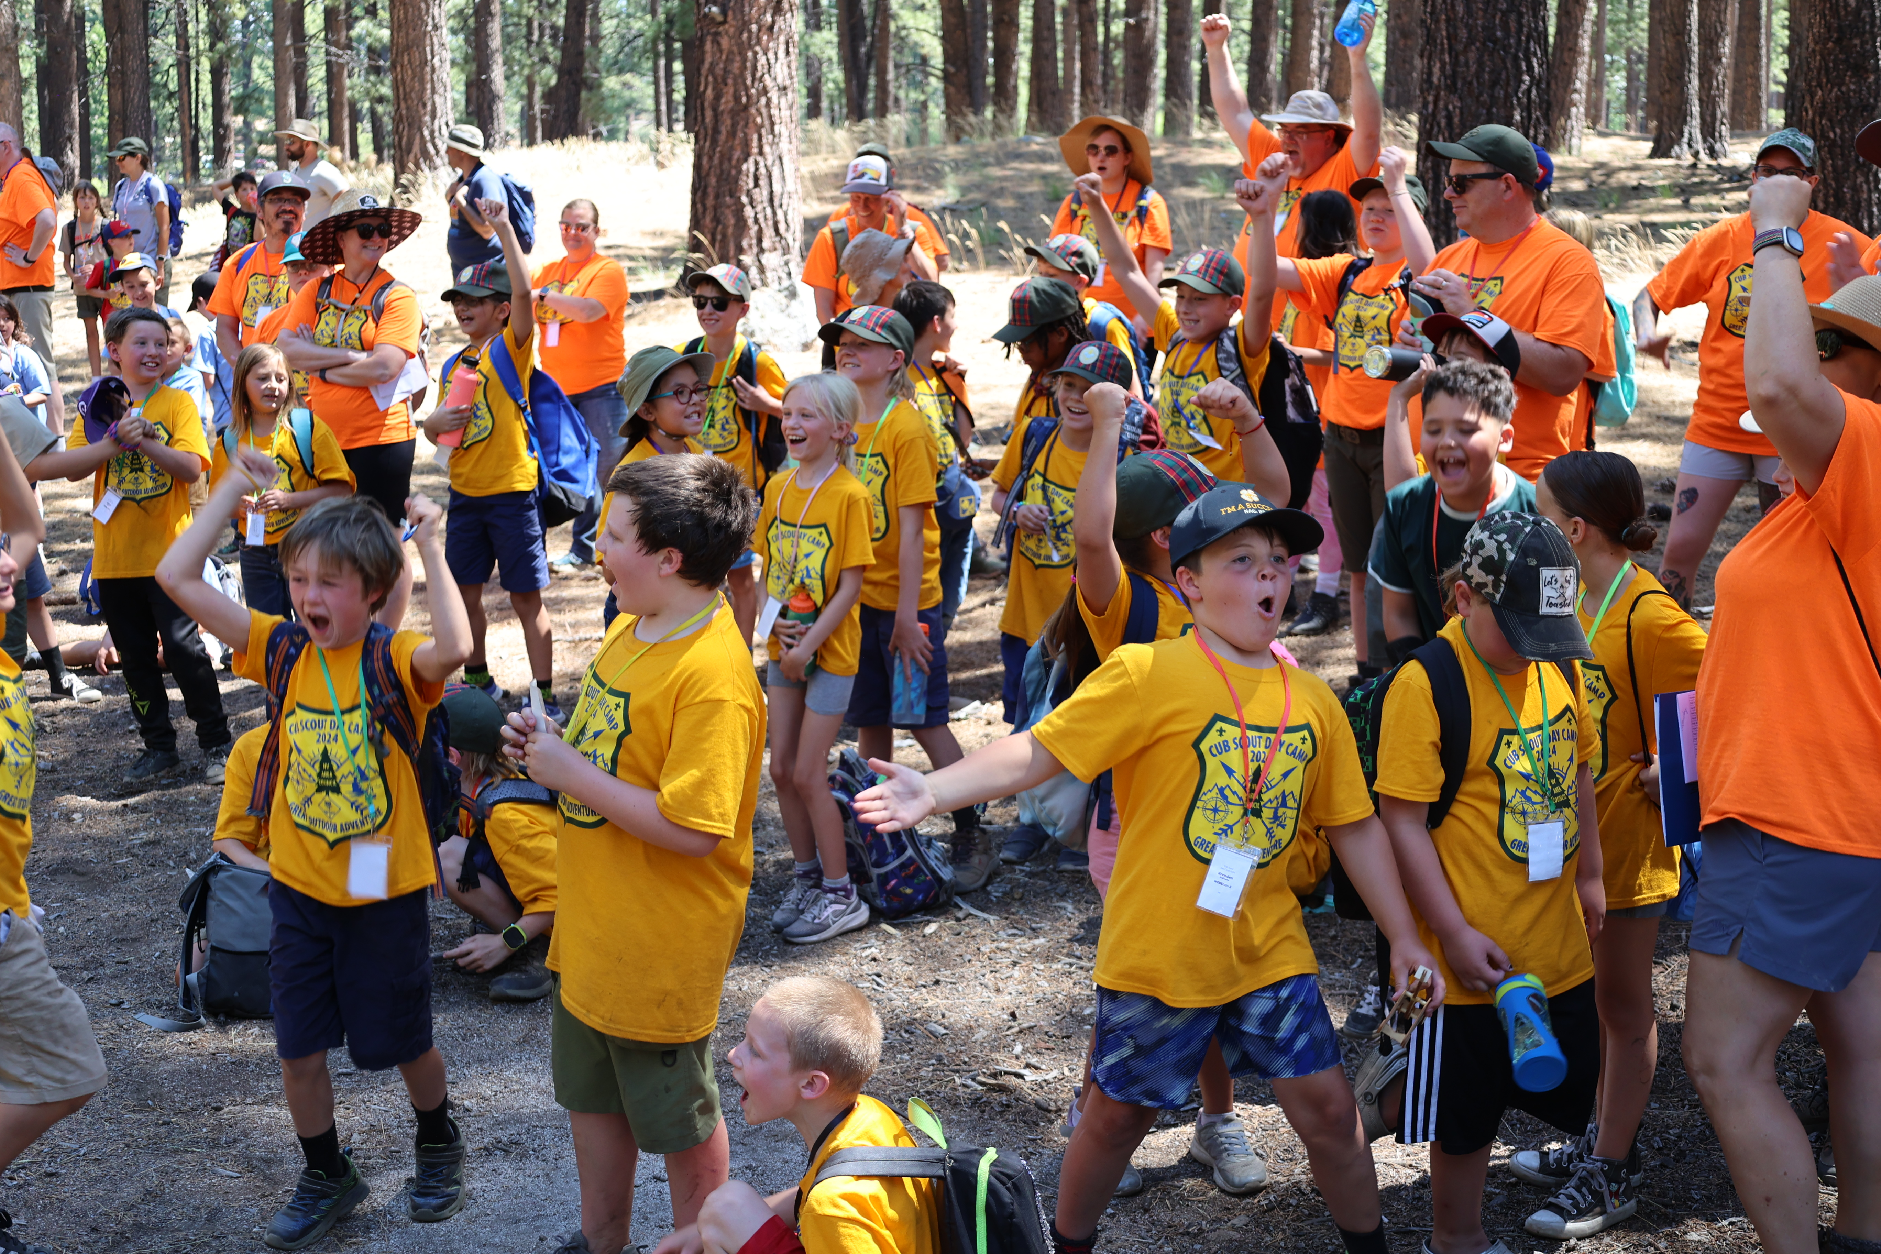  K Thru 5th Grade:  FUN WITH Cub Scout Pack ###  Cub Scouting is for families of Kindergarten through 5th Grade Boys and Girls – and their families! You can join now!  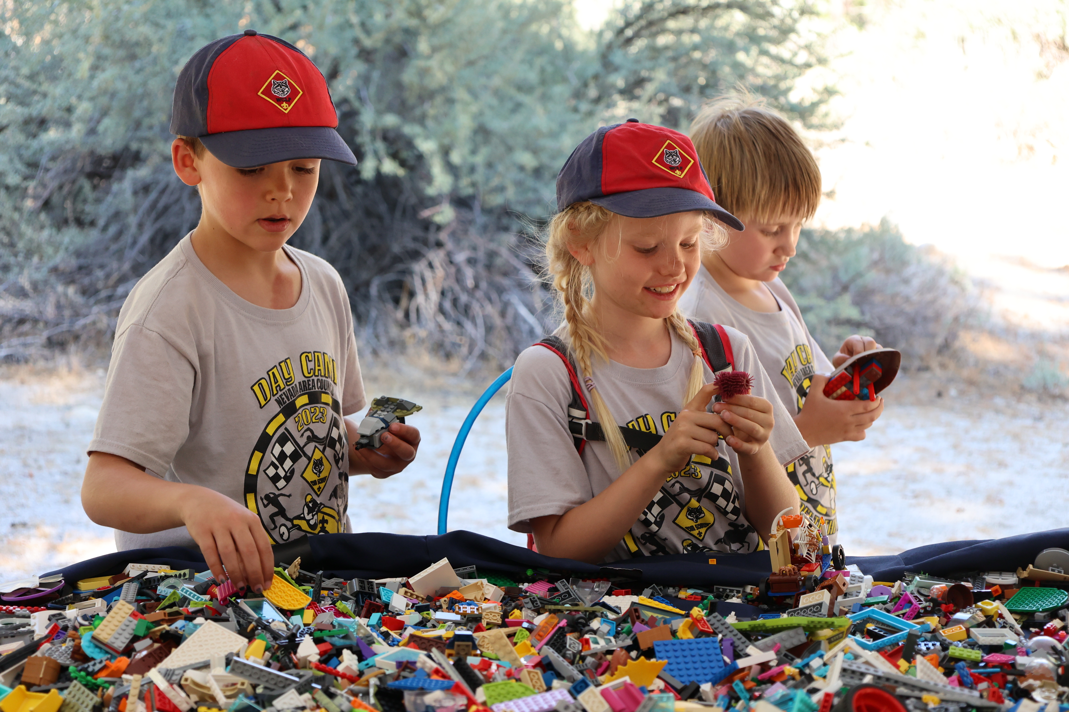  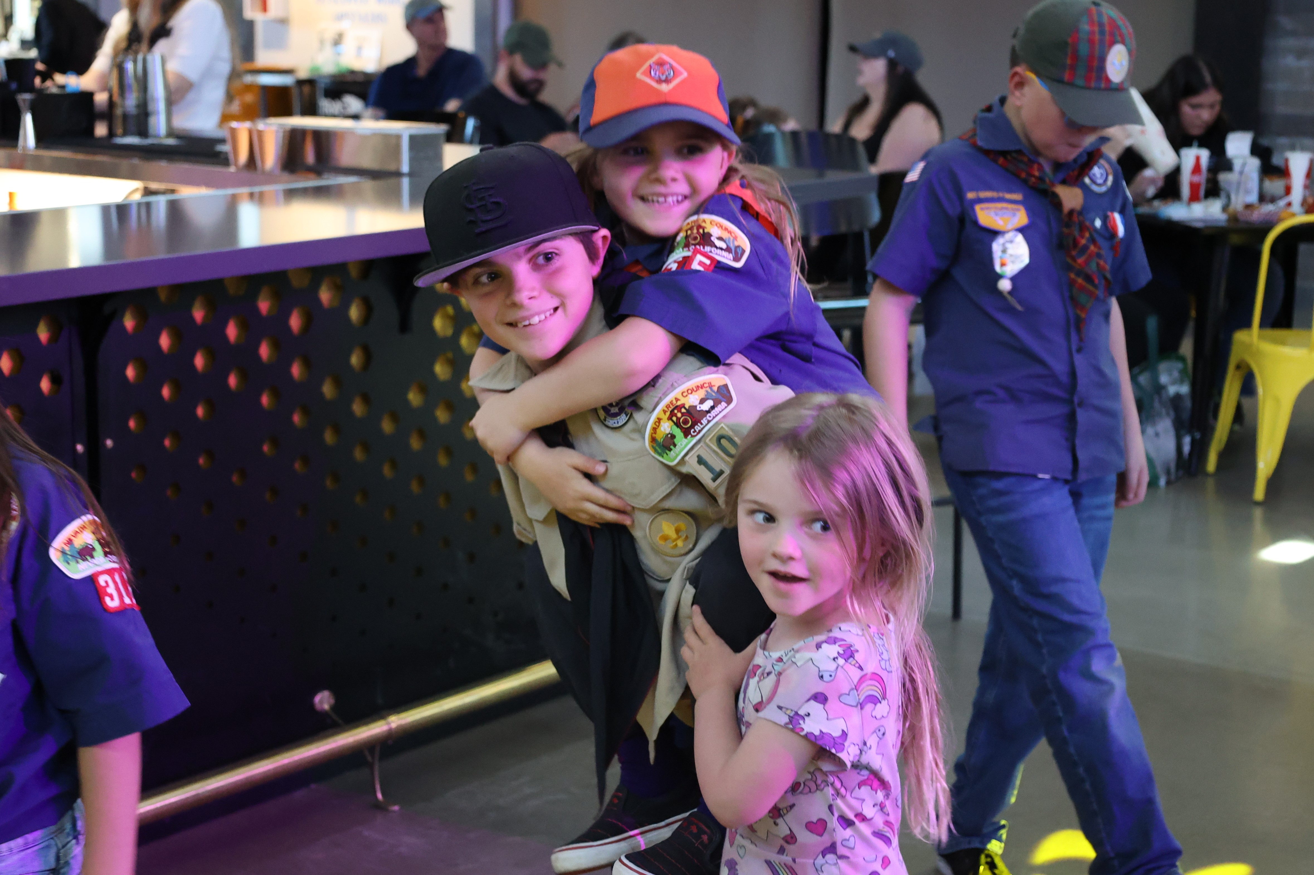  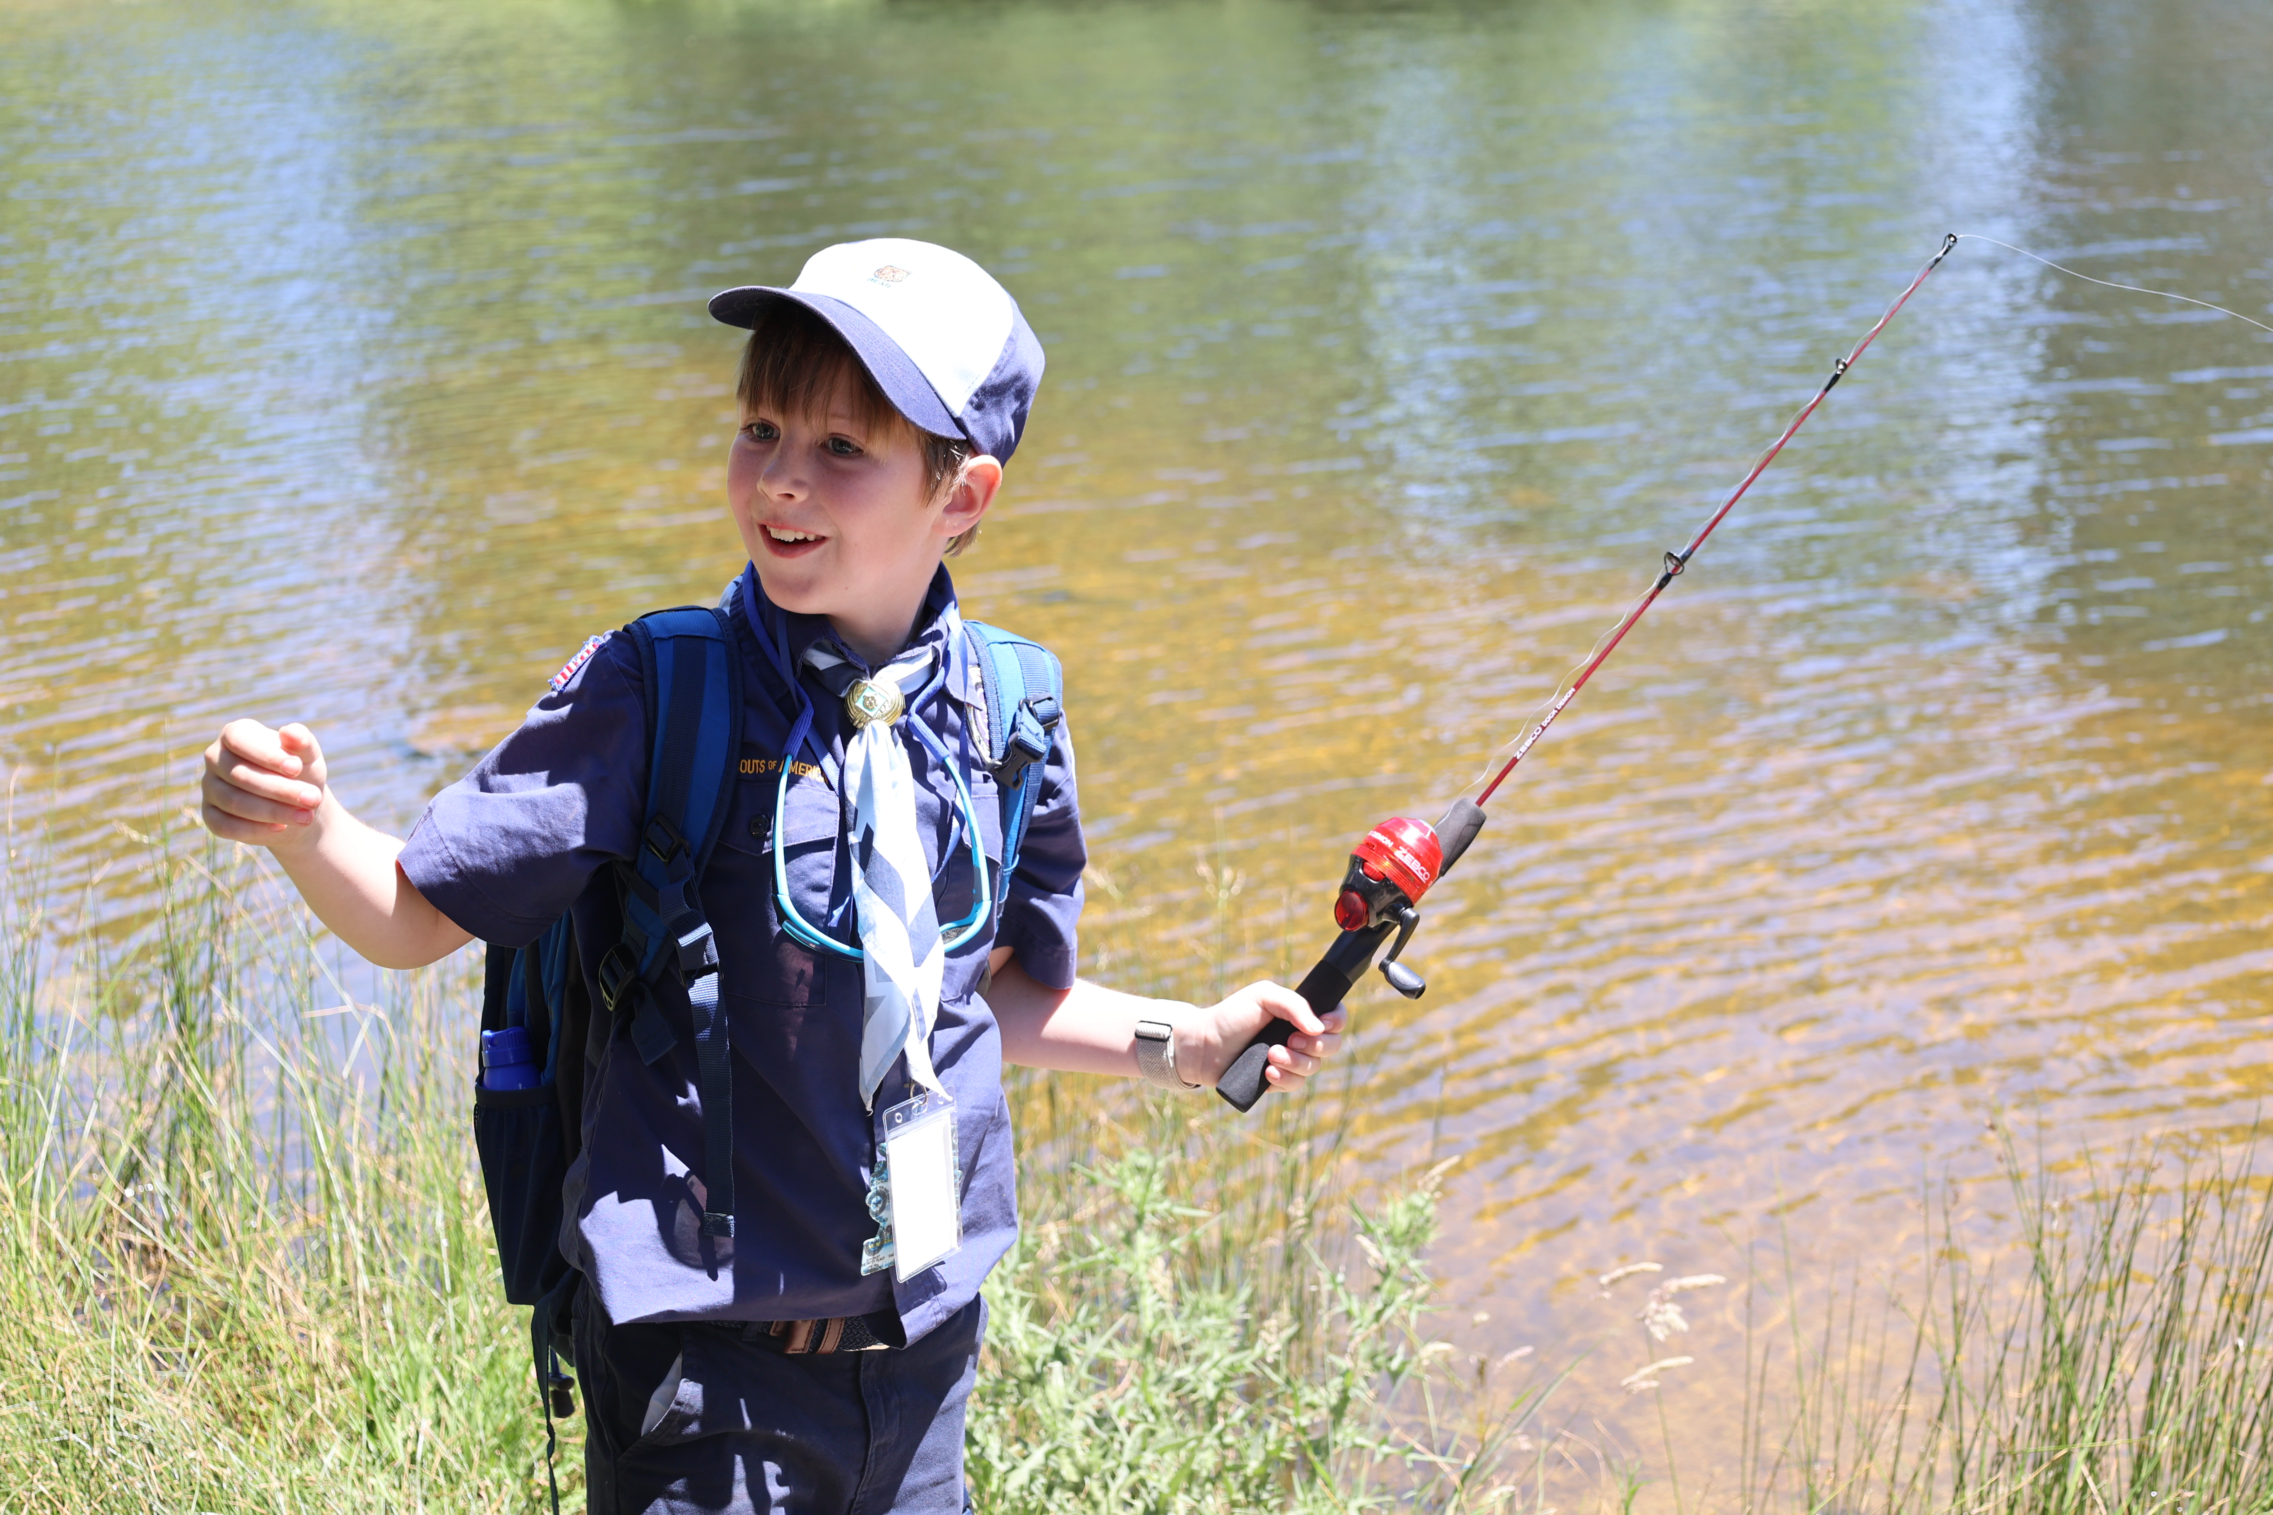 |  | Cub Scouting is Fun for Families!  What We Do:  race cars  biking  hiking  swimming  camping  fishing  cooking  sports  archery  field trips  games  and more!  Want more info?  Contact: (unit leader name)  ###.###.####  ___________@_____
Fun, Family, Friends, and Adventure. Join our Cub Scout Pack!
Cub Scout Pack ### is for boys and girls in Kindergarten through 5th Grade. A “Pack” has “Dens” of Scouts in the same grade (ideally 6 to 8, not more than 10) who do fun Adventures together, led by a team of parent leaders.
Every Scout can get a Handbook of Adventures and every family will receive lots of resources to bring the program to life as parent leaders lead their Scouts and Dens in those Adventures.

Here's some of the fun things that Cub Scouts in our Pack will do over the next year*:

- Kickball + Cookout on Saturday June 14 at ______________!
- Splash + Swim on Saturday June 28 at ______________!
- Let’s go Biking Back to the Pack on Saturday July 12 at ______________!
- A Welcome Back to the Pack Pool Party on Saturday August 2 at the ______________ lifeguarded pool, starting at __:00 _.m., and we’ll all celebrate being “back to school – in the pool”!
- Water Rocket Launch and Pack Cookout on Saturday August 16 at ______________!
- Walk in the Woods hike on Sept. 13, starting at __:00 _.m.
- Then we’ll do Our Big Spooky-Ree Weekend Campout October 24 to 26!
- Celebrate our Vets at the Veterans Day Parade in on Saturday, November 8.
- Service and Celebrate! We’ll do a Service Project December 13, with a party afterwards.
- Pack Pinewood Derby, on Saturday, January 24, 2026.
- Celebrate the Anniversary of Scouting with a Scouting for Food Drive, on Saturday, February 7, 2026.
- We will go Spring Camping April 24-26, 2026, at a new camp to be selected.
- Join our “Blue & Gold Awards Banquet” to recognize Scouts and Leaders, Friday, May 8, 2026
- We can go to one or more Cub Scout Day or Twilight Camps in June.
- June 13: Kites and Cookout.
- June 27: Splash and Swim.

Each grade level Den will have additional activities organized by parent leaders, doing what the Den families want to do as they Get Out and Cub Scout!
(* dates and activities may change + need organizers, and more may be added!)

