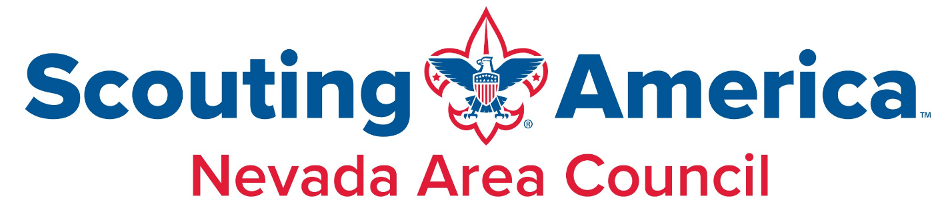
GOLD CARD REFERRAL FORM
Cub Scout, Scout, Sea Scout or Venturer to be awarded the Gold Card for recruiting.
- Name: _______________________________
- Unit # _______________________________
- Parent Name & Phone: __________________
- Email: _______________________________

Referred New Cub Scout, Scout, Sea Scout or Venturer
- Youth Name: _________________________
- Parent/Guardian Name(s): _______________
- Address: _____________________________
- City/State/ZIP: ________________________
- Phone: ______________________________
- Email: _______________________________
Submission Instructions
- Submit this completed form to your Unit Leader.
Unit Leader Approval and Instructions
I confirm that the Scout listed above has recruited the new youth member listed, and request the issuance of a Nevada Area Council Gold Card.
Unit Leader Name:_______________ Signature:___________________ Date:__________
- Submit this completed form attached to the new youth application and fees to your District Executive or to the Council Office. For online registration, provide new Scout ID # ______________
District Executive Approval
Name: _________________________ Signature:___________________ Date: __________

